SME Credit Guarantee Scheme and SME Credit Guarantee Scheme Designated for Special Projects Work Flow | Back to Index

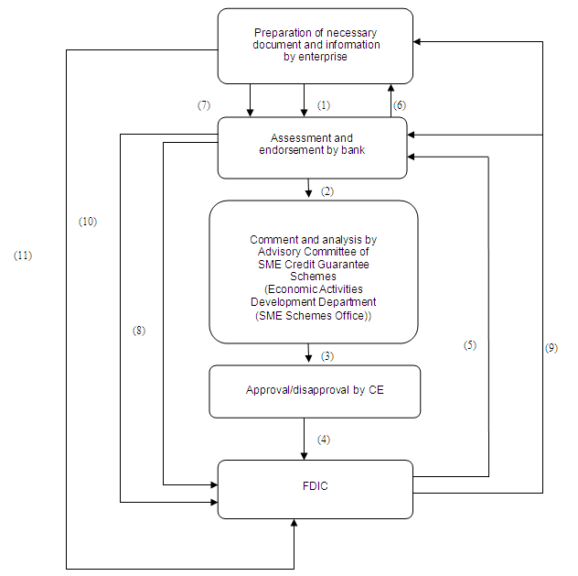
(1) | Before applying, SME read the “Introduction” of the schemes and prepare for the necessary document and information. Then they could contact the participating banks of the 2 Credit Guarantee Schemes to request for the loan and fill in the “Application Form”;
(2) | The bank submit the application to the Advisory Committee for the SME;
(3) | The Advisory Committee assesses the application and gives comment to the Chief Executive on whether to approve or not;
(4) | The Chief Executive approves/ disapproves the application through authorization and instruction, and informs FDIC of the result;
(5) | FDIC informs the lending bank of the approval of securing the loan through “Notification of SME Credit Guarantee”, and requests for provision of “counter-guarantee” by the enterprise so as to issue the “Confirmation of the Credit Guarantee ”;
(6) | The lending bank requests the enterprise to provide the promissory note for counter-guarantee;
(7) | The borrowing enterprise submits the promissory note for counter-guarantee to the lending bank;
(8) | The lending bank submits the promissory note for counter-guarantee by the enterprise to FDIC;
(9) | On receiving the promissory note for counter-guarantee, FDIC issues the “Confirmation of the Credit Guarantee ” for both the lending bank and the borrowing enterprise;
(10) | The bank must submit to FDIC copies of the loan contract and all other related documents within 90 days after the “Confirmation of the Credit Guarantee” is issued. In addition, the bank should start to submit semi-annually to FDIC the “Semi-Annual Status Report of the Guaranteed Loan”; for any incident occurred within the guranteed period, the bank should inform FDIC through “Bank Notification on Special Occasions During the Guaranteed Period”. If the lending bank decides to reject the granting of loan after the “Confirmation of the Credit Guarantee” is issued, it should inform FDIC immediately of the decision;
(11) | Every year the borrowing enterprise should submit to FDIC its Declaration Form of Complementary Tax; in case of any incident needed to report, it should inform FDIC through “Enterprise Notification on Speical Occasions During the Guaranteed Period”.

SME Aid Scheme Work Flow | Back to Index
